FaithWalkers 4 in Worship
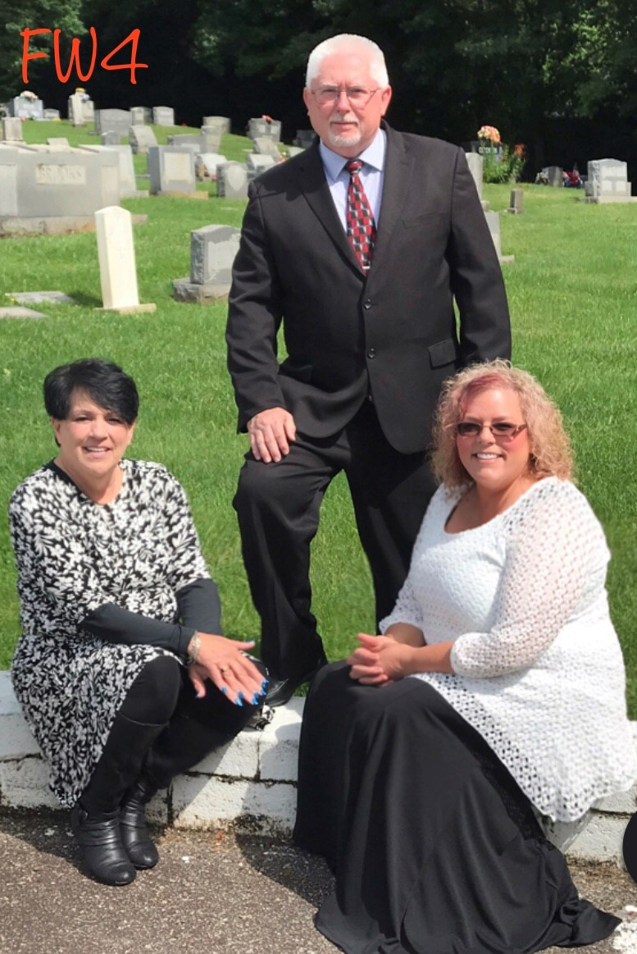

Date: ____________________________________________________

Time: ____________________________________________________

Location: _________________________________________________

